Monday 10th May 2021
Family First Aid  12:30-2:30pm  (just this session)  Delivered online | This workshop will give you an introduction to first aid. It will give you current advice for young children such as dealing with choking, CPR and burns. | To book onto this session please copy/click link: https://tinyurl.com/mpszb8uy
How Food Affects our Mood  7:00-9:00pm  (just this session)  Delivered online | This workshop will explore how the food we eat impacts on our moods. | To book onto this session please copy/click link: https://tinyurl.com/y847jhff
Tuesday 11th May 2021
Coastal Collage  9:30-11:30am  And Thursday 13th May 2021  This is delivered face to face at ACL Maldon | A chance to have some fun making a coastal collage. FREE creative session to inspire you. These two sessions are aimed at parents/carers with their pre-school children, although all ages are welcome. The first session we will look at how we can make the most of a walk along the coast, river or canal, think about the sort of items we might find, look at some collages, make something to take home, and finish with a story. Hopefully you will be able to take a walk and find some bits over the following week, or if not, find some bits you can use, ready for the second week to make your collage. | To book onto this session please copy/click link:  https://tinyurl.com/CoastalCollage
Getting Children to Listen  9:30-11:30am  (just this session)  Delivered online | Communication is key in any team, and a family is no different! Do you feel like you are on repeat? Why not come along to our FREE workshop - on How to talk so your kids will listen. | To book onto this session please copy/click link:  https://tinyurl.com/getting-children-to-listen
French is fun  12:30-2:30pm  (just this session)  Delivered online | Learning a second language at an early age can help boost memory retention and concentration. On this workshop you will learn different games and activities to boost your child's knowledge in French. Learn about which websites are best for French education. French is Fun. Help give your child find the `joy of languages | To book onto this session please copy/click link:  https://tinyurl.com/rrby6yy8
Understanding Anxiety  7:00-9:00pm  (course over 2 weeks)  Delivered online | A course to support you and your family to help understand the different types of anxiety and the impact it can have on family life. | To book onto this session please copy/click link: https://tinyurl.com/ynsdvbs9
Wednesday 12th May 2021
Get your child’s school to listen  9:30-11:30am  (just this session)  Delivered online | This course will help you understand the techniques to be an advocate for your child/ren and communicate with your child's school/setting constructively to help them listen to your concerns/feedback as a parent/carer/guardian. | To book onto this session please copy/click link:  https://tinyurl.com/getting-school-to-listen
Thursday 13th May 2021
Wellbeing for Primary children  9:30-11:30am  (just this session)  Delivered online | An opportunity to have guided support and tips on keeping your children of 5-11 years emotionally well. | To book onto this session please copy/click link:  https://tinyurl.com/Wellbeing-for-primary-school
Developing Growth Mindset  4:00-5:30pm  (just this session)  Delivered online | Children are under more pressure than ever to learn due to missing so much valuable teaching time during lockdown. This workshop explores how we can help our children to develop a growth mindset. Once this is in place they can learn, grow and thrive. For parents and children together | To book onto this session please copy/click link:  https://tinyurl.com/b8x2bfr4
Introduction to mindfulness for children  4:30 – 6:00pm  (just this session)  Delivered online | How are you feeling? Are you managing to balance family life or is it stressful. Take this time for yourself to be able to relax and be mindful of your surroundings. You can then transfer these new skills to your family life and teach your children. | To book onto this session please copy/click link:  https://tinyurl.com/rm2w22hm
Family First Aid for 8 year old + and their parents  7:00-9:00pm  (just this session)  Delivered online | This workshop will give you an introduction to first aid and will help you to teach your older children essential basic life-saving skills. | To book onto this session please copy/click link:  https://tinyurl.com/25n68xw9
Saturday 15th May 2021
Family Scavenger Hunt  10:00-13:00  Fairfield, Ingatestone  This is delivered face to face | Come along and have some Family Fun whilst looking for items along the way. | To book onto this session please copy/click link:  https://tinyurl.com/coastal-scavenger-hunt
Monday 17th May 2021
Anxiety in children of pre-school age  7:00-9:00pm  (just this session)  Delivered online | Are you concerned about your pre-school child displaying behaviours associated with anxiety. If anxiety and fear is extreme, it is always best to involve a mental health professional and receive an expert opinion, this can be done through your GP or health visitor. However, as a parent, there is much you can do to help your anxious or fearful child. This workshop will explain what you can do to support your child and understand the meaning behind the behaviour. | To book onto this session please copy/click link:  https://tinyurl.com/anxiety-in-preschool-children
Assertive Parenting Toolbox  12:30-2:30pm  (just this session)  Delivered online | This workshop will explore what tools we have as parents in our toolbox and how we can make them more assertive | To book onto this session please copy/click link:  Booking opens Monday 10th May
Tuesday 18th May 2021
Routines Rule  9:30-11:30am  (just this session)  Delivered online | A workshop to support you and your family to set routines that work for you and your family. Routines are important for a lot of different reasons, which will explored throughout this session. It is important that as parents we make sure routines are predictable, that we balance the routines to include adult led time and child-initiated activities, that children have time to successfully complete routines and that they include individual differences if you are parenting more than one child. | To book onto this session please copy/click link:  https://tinyurl.com/ydhxjnpt
Developing your child’s writing toolkit KS1  1:00-3:00pm  (just this session)  Delivered online | This course is going to give you the confidence to support your child with their English learning. It will give you the current information on what your child will learn in KS1, explain any jargon used and give you practical tips on making English fun. | To book onto this session please copy/click link:  https://tinyurl.com/uvnhx5au

Dads are you an equal parent?  6:30-8:30pm  (just this session)  Delivered online | To explore the challenges that fathers face parenting their children, both within a relationship or when separated/divorced. Fathers play an important role in the lives of their children. Children who have supportive, close and positive relationships with their fathers do better mentally, academically and physically in life. In addition, studies have shown that children whose fathers embrace being a parent confidently have lower levels of behavioural issues as teenagers. This will support you with your parenting role as a father and enable you to have a more active and balanced parenting role. | To book onto this session please copy/click link:  https://tinyurl.com/Dads-workshop-May
Wednesday 19th May 2021
Dealing with anger in the family  12:30-2:30pm  (just this session)  Delivered online | Anger in the family can cause long lasting detrimental effects. Learn how to work together and communicate. Discover methods to ensure you can calm down. A course for the whole family, adults and children. | To book onto this session please copy/click link:  https://tinyurl.com/rwv9zua9
Break the plastic cycle  10:00-12:00  (course over 2 weeks)  Delivered online | This workshop will give you hints and tips on how you can make the most of recycling and encourage your children to take part to protect their future. | To book onto this session please copy/click link:  https://tinyurl.com/h7kj3zbt
Thursday 20th May 2021
Coastal Science Experiments  12:30-2:30pm  (just this session)  Delivered online | The beach offers some fabulous opportunities to conduct experiments. Learn about which experiments work best at the beach and where in Essex to conduct them. | To book onto this session please copy/click link:  https://tinyurl.com/Coastal-Science-ExperimentsMay
Creating a positive digital footprint  4:30-6:00pm  (just this session)  Delivered online | This workshop is for all ages – parents and children. Do you know what a digital footprint is and how a negative footprint can affect your and your children’s job prospects? Learn how important it is to think before you post. | To book onto this session please copy/click link:  https://tinyurl.com/yp9p65f2

And for our full list of FREE upcoming courses that are available, click here.

Please feel free to share with anyone else you feel would benefit, living in Essex.

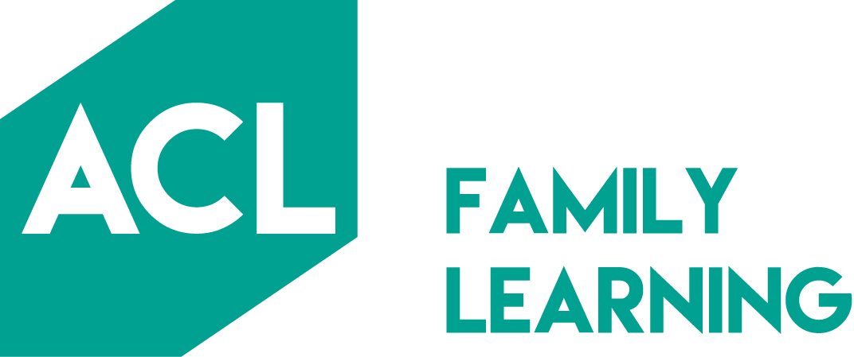

For more information please contact us:

Melissa Williamson
Curriculum Lead Community
Social Mobility and Inclusion Team
Adult Community Learning
Essex County Council
Tel: 03330321597
Email: Melissa.williamson@essex.gov.uk

Zoe Mallett
Curriculum Lead Community
Social Inclusion and Mobility Team
Adult Community Learning
Essex County Council
Tel: 03330321372
Mobile: 07740 900529
Email: zoe.mallett@essex.gov.uk

